Analyzing MLB Teams’ Performances Regarding Contact Vs. Power

Introduction and Background
The sport of baseball has existed for over a century in the United States spanning different leagues and regions. As of 2026, it is most recognizable with the Major League Baseball (MLB) association hosting 30 teams split between the American League and National League. Each league has 3 divisions with 5 teams each competing in a 162-game season from March to September where the best teams then play in the postseason to win the World Series. Within these games of baseball, batters differ wildly with how they tend to hit the ball with some grounding the ball and managing to get it past the infielders and others blasting the ball into the outfield and even into the seats for a homerun. This is usually how contact hits and power hits are separated: contact hits have lower angles and result in a single most of the time while power hits are faster and higher moving balls that lead to doubles, triples, and home runs which are all considered extra base hits.

Within that distinction lies an inquiry I wanted to answer: how do the ratios of contact hits and power hits contribute to a team’s success in terms of winning seasons and postseason runs? MLB is filled with talented offensive power and that’s not getting into the defensive side of things, but is there a pattern that emerges with how that offense is utilized on the top teams? This is something I decided to investigate given how varied batting is across the league as well as curiosity with seeing how powerhouse teams can be boiled down to whether they tend to hit the ball short and well or long and with a lot of force. This will also provide an opportunity to explore a controlled and grounded approach to analyze baseball statistics amidst the complexity of its advanced categories. This project aims to showcase how simple statistics are incorporated into baseball to provide a glimpse into its data and what insights can be pulled from contact versus power.

Dataset Materials
For this project’s data sources, I decided to use the Lahman Baseball Database provided by the Society for American Baseball Research [1]. This site’s mission is to document historic pieces of media across different iterations of baseball’s structure and part of that is a database tracking seasons of MLB stats within teams, people, and locations. These subsets of data are sorted into different CSV files containing tables. The files featured in the analysis are the Teams (team information and win records per year), Batting (box score statistics of players per game in the regular season), Post-batting (same as batting but for the post-season), and Series tables (records of winners and losers in each post-season series).

Cleaning and Processing Methods
These files would be loaded into Python as Pandas dataframes for data cleaning and analysis. As far as timeframe is concerned, I selected 10 seasons of data from 2015 to 2025 with the exception of the 2020 season due to its different structure and timing in response to the COVID pandemic. Once filtered out, the foundation variables can be calculated through the Batting and Post-batting tables. The ‘1B’ column representing singles is used to form the variable ‘contact_hits’ for every player while the ‘power_hits’ variable is made by adding the ‘2B’, ‘3B’, and ‘HR’ columns together with those representing doubles, triples, and home runs respectively. Afterwards, I divided the number of contact hits and power hits by the total number of hits per player per game and then multiplied by 100 to get the percentage variables of ‘con_%’ and ‘pow_%’ respectively. From there, it would be a matter of using Pandas groupby functions to gather average ratios per team per year and merge functions with the Teams table to match the records of each team for each season.
Next came the matter of assigning attributes to the teams that have participated in the post-season. I should also note how the structure of the MLB post-season is incorporated into the dataset. Since 2012, the post-season has been divided into four rounds with each league (American and National) having a wild card game, two best-of-5 division series, a best-of-7 league champion series to denote the winner of each league, and finally the best-of-7 World Series to mark the champion. However, the 2022 season and beyond has reformatted the wild card game into two best-of-3 series. For the sake of consistency, I will be marking all wild card games under the same category. To track how far each team made it into the post-season, I used the Series table to link together the winners and losers of each series, assign a value 1-4 based on the series they participated in, and took the max value of the series to assign a ‘playoff_depth’ variable to the Batting table. The ‘playoff_depth’ variable runs from 0-4 where 0 means no playoffs that year for that team and 1-4 goes through the four levels of the post-season as mentioned above. Using the Series table once again, I took the winners of the World Series and put their Batting table info and stats into a champions table. Along with this, I created separate tables for different win brackets: 85-89, 90-94, 95-99, and 100+ wins in a season. With all the setup for the data tables complete, I delved into the tables to analyze how the contact and power hit ratios looked.

Summary Statistics Overview
Moving forward, most of the contact/power ratio numbers will come from the regular season (Batting table) stats since it’s more consistent with its data and there are more games to view. To start off, I decided to look at some summary statistics regarding the contact and power hits:
Contact/Power Hit and Ratio Distribution (30 teams across 10 seasons):
 | Mean | Std. Dev. | Min | 1st Quartile | Median | 3rd  Quartile | Max
# of Contact Hits | 878.91 | 60.798 | 746 | 831 | 873 | 921.25 | 1031
# of Power Hits | 486.467 | 49.03 | 368 | 452 | 482 | 519 | 648
Contact % | 64.383 | 2.784 | 57.496 | 62.482 | 64.367 | 66.486 | 72.888
Power % | 35.617 | 2.783 | 27.112 | 33.514 | 35.633 | 37.518 | 42.504

Looking at the stats across the board, the high number of contact hits jump off the board with nearly double the amount over power hits. The ratios similarly reflect this as on average, there is nearly a 2:1 ratio of contact to power.
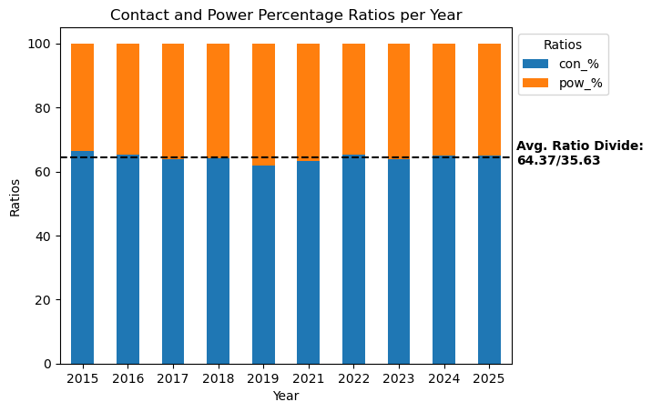
Figure 1: A stacked bar chart with ratios of contact and power per year.
As there is a consistent trend of contact having a higher ratio than power, this will be a variable to continue looking at with future visualizations. However, there are some instances such as the 2019 season appearing to have a higher power ratio than the others. To look at more examples of league wide data, I constructed another stacked bar chart to view post-season ratios:
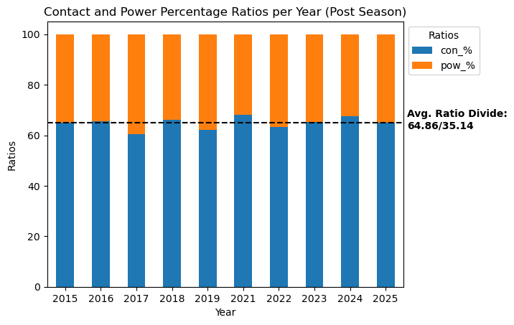
Figure 2: A stacked bar chart with post-season ratios of contact and power per year.
The post-season stats appear to have a slightly higher contact hit ratio than the regular season average. This gives the idea that contact hits tend to make up around 64-65% of hits in the league. However, there was still the opportunity to check for any patterns emerging from top performing teams. Given the small size of post-season stats compared to the regular season, I took the approach of seeing the hit ratios of high-ranking teams.

Data Analysis of Ratio Hits
Continuing with the post-season angle, I divided the regular season data into six categories: teams who missed the playoffs, teams with the highest series level they achieved in the post-season, and teams who ended up winning it all.

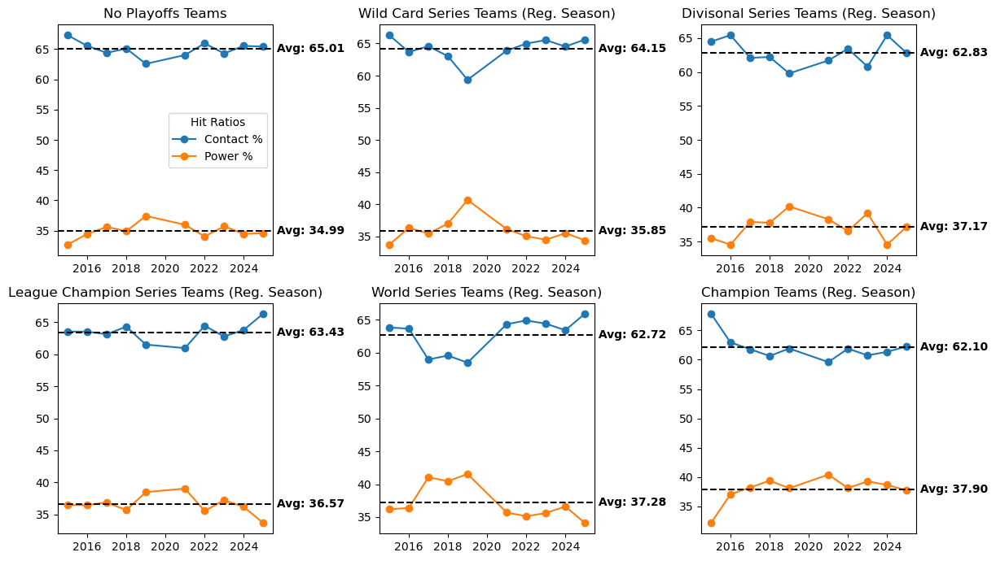
A lot of points are examined here (such as the 2019 season jump in power), but the main takeaway is with the ratios going left to right, top to bottom; there appears to be a higher power ratio as teams make a deeper playoff run. To view these differences in a more concise manner, I plotted the differences of these ratios to the regular season averages (as those seen in Figure 1):
Figure 3: Six line subplots indicating the contact/power hit ratios per year of different performing teams
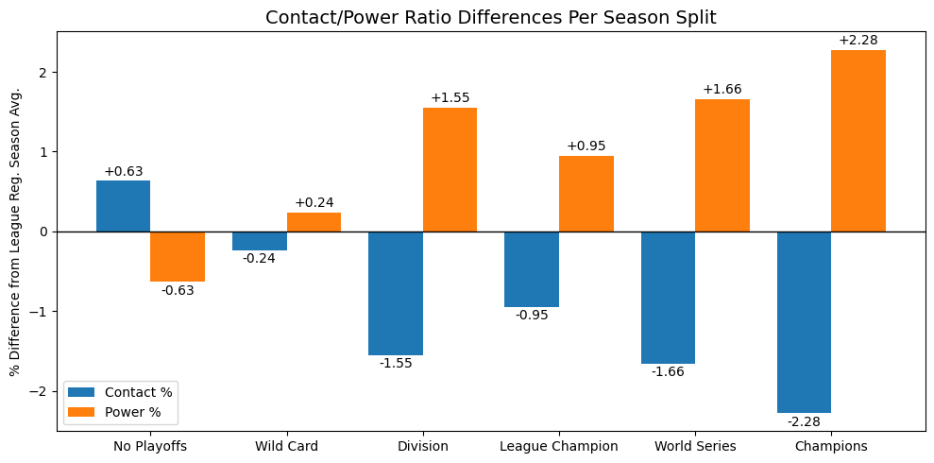
Figure 4: A diverging bar graph with the differences in ratios of the six categories plotted. Note that contact/power ratio difference is calculated with the regular season league contact/power ratio averages
Now with the differences in ratios compiled together, we can see how there is a noticeable trend to the right of power ratios being higher than the league averages. This seems to showcase how better teams tend to get more out of their at-bats and win more often than not. To cross-reference this, I viewed this same structure in the win bracket data I created.
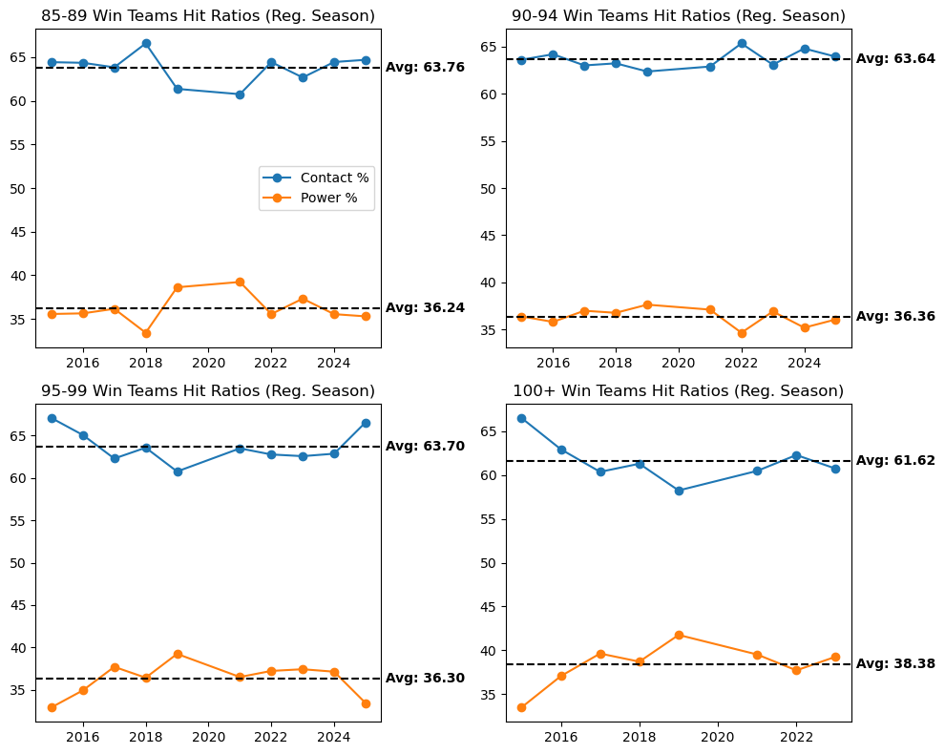
Figure 5: Four line subplots indicating the contact/power hit ratios per year of different # of wins teams. The 100+ win team plot has 2 missing seasons in the data due to not every season having a 100+ win team.
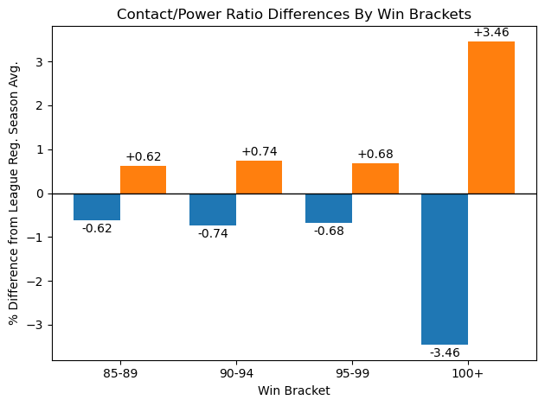
Figure 6: A diverging bar graph with the differences in ratios of the four win brackets plotted
There’s less of a gradual trend with this version of the data, but the same vision can be seen with it; not only is there a large difference in power comparatively with the 100+ win bracket, but all of the win brackets tend to have a larger power ratio than the league average.

Machine Learning Implementation
To see if the increased power ratio idea lends well to models, I decided to view a machine learning approach to the ‘W’ (wins) and ‘postseason_depth’ columns. First, I viewed a correlation matrix to see how variables interacted with each other.
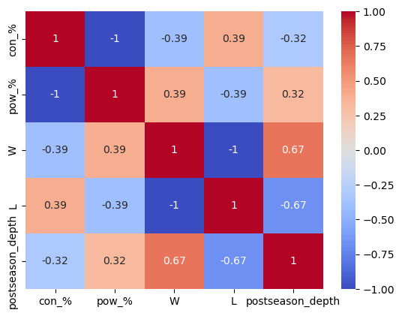
Figure 7: A correlation matrix with con_% and pow_% interacting with different variables
Here we see that ‘con_%’ has a negative correlation with wins and post-season depth while ‘pow_%’ has the inverse. Keeping this in mind, I decided to move on with the models for the variables mentioned. For wins, I went with linear regression and random forest as the win column is continuous and these models can provide model performance in that regard. For post-season depth, I went with both regular logistic regression as well as an ordinal version seeing as I’m dealing with a multi-class variable and the categories are order in terms of post-season level.
Finally, I ran some cross validation and grid search functions to cover all of my bases and cross-reference my models.

Regression Models for Wins:
Type of Model | R-squared Score | Root-Mean Squared Error | Mean Absolute Error | Coefficients | Importances
Linear Regression | 0.0921 | 11.1676 | 8.8451 | Con_%: -2.76  Pow_%: 2.76
Random Forest | -0.6780 | 15.1804 | 11.7720 |  | Con_%: 0.501  Pow_%: 0.498

Scores Per Classification Models for Post-Season Depth:
Type of Model | Accuracy | F1 Score | ROC-AUC | Coefficients | Features
Random Forest | 0.3555 | 0.3767 | 0.40180 |  | Con_%: 0.501  Pow_%: 0.499
Logistic Regression | 0.6444 | 0.5051 | 0.5868
Ordinal Regression | 0.6333 | 0.5488 | 0.5715 | Con_%: -0.40  Pow_%: 0.40

Reference Scores for Post-Season Depth:
Type of Model | Accuracy | Details
Cross Validation | 0.64 | 10-fold cross validation accuracy scores: 0.66666667, 0.66666667, 0.63333333, 0.63333333, 0.66666667, 0.66666667, 0.63333333, 0.63333333, 0.63333333, 0.56666667
Grid Search | 0.64 | Best grid parameters: {'C': 1e-07, 'penalty': 'l1', 'solver': 'saga'}

When testing the models, I experimented with adding a value of 5 to the ‘postseason_depth’ variable to represent the champions. However, it appeared to make the models lose score across the board, so I removed the change. Unfortunately, it appears that the models weren’t able to score that highly with Random Forest providing poor/contradictory results, Linear Regression showing low correlation, and the classification models having somewhat low accuracy/F1 scores. This could be due to the small differences in ratios between top teams and average teams and/or due to the nature of a lot of teams missing the postseason. However, the models appear to be mostly consistent with each other where the coefficients mark higher power ratios as better for wins and post-season depth. As such, the models seem to fall in line with the visualizations regardless of the somewhat low scores.

Discussion of Results
Overall, an answer did seem to be prevalent across the data regarding the ratios of contact/power hits; while the majority of hits in the MLB dataset are contact hits for singles, the top performing teams with high win counts and deep post-season runs tend to have a higher power hit ratio compared to the averages. This means that on average, better teams are able to produce more doubles, triples, and home runs compared to the average team’s ratio. The difference in power hit ratios is a bit slim provided that contact hit ratios never seemed to dip below 60%, but when adding up all the players throughout numerous chances to bat, a more powerful swing of the bat could make all the difference through the long season run.

Conclusion/Reflection
I believe the dataset allowed an intriguing exploration on how different teams fared in their seasons along with providing an extensive collection of data going down to an individual player’s single instance at batting for one game. This was able to be expanded upon for league-wide and multiple year observations. However, there were still some variables that could have provided a deeper look into the topic of contact versus power: exit velocity (how fast the baseball began to travel once hit) and launch angle (the angle of the arc the baseball travels when hit). These variables could’ve given more chances of analysis as to whether top teams tended to have slow/fast exit velocities and low/high launch angles. Another aspect was that the approach I used for looking at top teams only accounted for hitting; there’s still the other half of baseball with pitching (and fielding) that might require a broader question such as “Do teams hit better when their pitchers do better?”. Defense aside, there could be other ways to expand this project with contact versus power with consideration of other variables such as how often these teams have sacrifice bunts compared to sacrifice fly outs or looking at the number of runs batted in (RBIs) through contact hits versus power hits.

Appendix for Sources
[1] Home page for the Lahman Baseball Database: https://sabr.org/lahman-database
Description of database structure: https://sabr.app.box.com/s/2q4p9j72orkim18j9ghjjqfras5m68nl/file/2084264159478
List of different tables: https://sabr.app.box.com/s/y1prhc795jk8zvmelfd3jq7tl389y6cd

